**LAB 3**

**AIM: Perform the following tasks:**

1. **Calculate the brightness and contrast of images.**

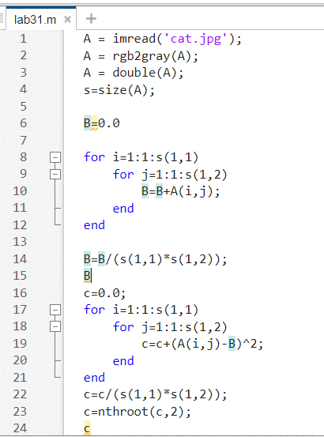

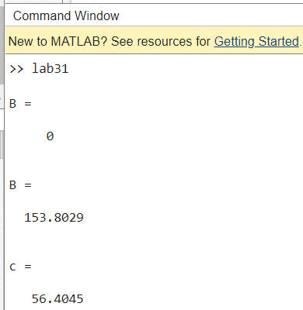

1. **Perform AND, OR and NOT logical operations on the images**

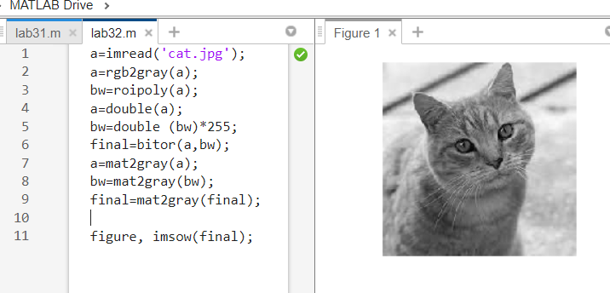

1. **Perform Image Shrinking Operation on the image**

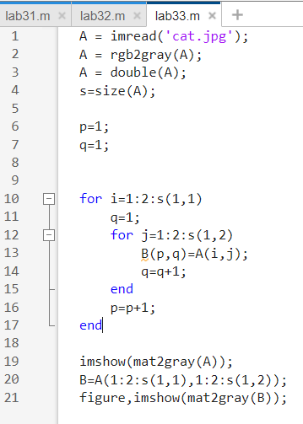

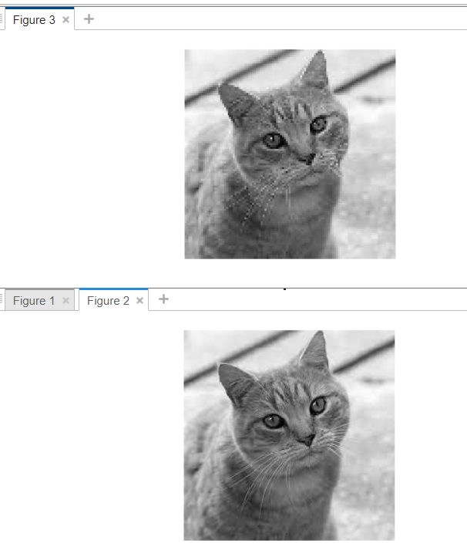

1. **Perform Image Transformation (Rotation)**

